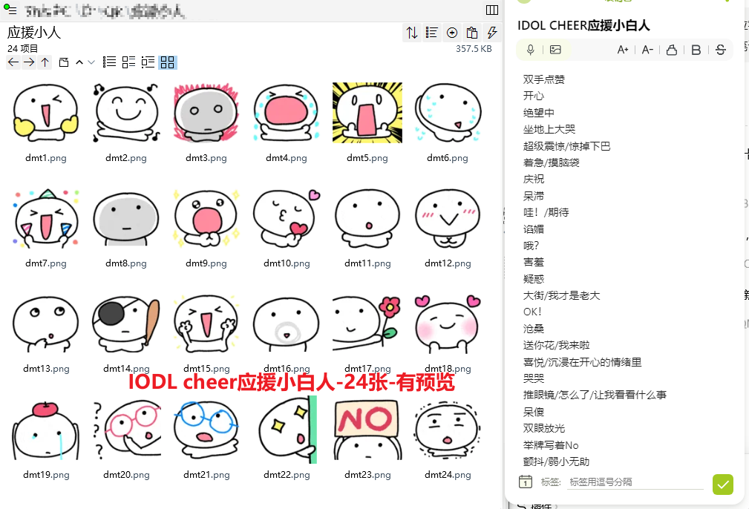
双手点赞:https://imgbed.heliar.top/i/oze8WzQOVEw3Xg8v_dmt1.png
开心:https://imgbed.heliar.top/i/RfIxY2XQTvdtiC0h_dmt2.png
绝望中:https://imgbed.heliar.top/i/CgI8XtHieuvwWE49_dmt3.png
坐地上大哭:https://imgbed.heliar.top/i/8qtpMs7ixaLU1Ijv_dmt4.png
超级震惊/惊掉下巴:https://imgbed.heliar.top/i/YS-BGX21C2JGrbVl_dmt5.png
着急/摸脑袋:https://imgbed.heliar.top/i/OSgoSZIwukCPgWCk_dmt6.png
庆祝:https://imgbed.heliar.top/i/4zbdR4C1vMn0JE8i_dmt7.png
呆滞:https://imgbed.heliar.top/i/7issZfpl4BumcaMI_dmt8.png
哇！/期待:https://imgbed.heliar.top/i/4gq3SkI63YSVpbDk_dmt9.png
谄媚:https://imgbed.heliar.top/i/cpNfGRCTOxPootKQ_dmt10.png
哦？:https://imgbed.heliar.top/i/SeySyf5LG25_XLz6_dmt11.png
害羞:https://imgbed.heliar.top/i/gwRNRQNRo_vmCA8-_dmt12.png
疑惑:https://imgbed.heliar.top/i/PPc-X99nBhNjQh2v_dmt13.png
大街/我才是老大:https://imgbed.heliar.top/i/SxqzcOVye94IjJHX_dmt14.png
OK！:https://imgbed.heliar.top/i/r9SzmhW7-0HtTI9s_dmt15.png
沧桑:https://imgbed.heliar.top/i/B-D6a38g_VhADHfy_dmt16.png
送你花/我来啦:https://imgbed.heliar.top/i/9nnYunk7CoNhracm_dmt17.png
喜悦/沉浸在开心的情绪里:https://imgbed.heliar.top/i/BBmYJF_KLkq9wtbg_dmt18.png
哭哭:https://imgbed.heliar.top/i/v6wWib7uL2t-w7pA_dmt19.png
推眼镜/怎么了/让我看看什么事:https://imgbed.heliar.top/i/zxpTKib97pqe0EwQ_dmt20.png
呆傻:https://imgbed.heliar.top/i/-tK8ELX_x-5YfifR_dmt21.png
双眼放光:https://imgbed.heliar.top/i/LyoqoTauF1uLKmPp_dmt22.png
举牌写着No:https://imgbed.heliar.top/i/nZoxug2GoejxRcIi_dmt23.png
颤抖/弱小无助:https://imgbed.heliar.top/i/tYAI5_jGzbiIPeJO_dmt24.png

